Computer Vision Application In Healthcare With Review-Study On Breast Cancer Detection Systems

Nishant Ranjan Verma  
Department of Computing  
Letterkenny Institute of TechnologyLetterkenny, Ireland  
L00157133@student.lyit.ie

*Abstract*— Computer Vision has been pivotal in many areas of life currently. It’s application has been widely used in the field of healthcare, retail, ecommerce among others. In the recent years the field of healthcare have readily started using Computer Vision techniques for various purposes. One such area is the early detection systems for Breast Cancer. Breast Cancer is a dangerous disease for women around the world. Many women have faced serious health conditions because of it. In this paper we will see the applications of Computer Vision in general and then try to focus specifically in detail abouts it’s recent works in Breast Cancer Detection. Also I will discuss some application of computer vision with related works examples in doing detection, classification, localization.

Keywords—computer vision, CAD, CNN, machine learning, deep learning

# Introduction

The biggest application of all the machine learning and deep learning has been making the machines/computers learn and be better at helping humanity in many of the tasks which previously required excessive efforts and highly trained skillset workforce. With the boom in the data in the present times, the ability of machines to learn and be better at it’s specific task has increased manifold. Computer Vision is one such branch of Deep Learning which has benefited in huge number with such advancements. These applications have enabled many organizations fine tune many of their systems in direct synchronization with Artificial Intelligence. Healthcare Domain has widely used the technology associated with Computer Vision in multiple instances.

# Computer Vision And HeathCare Application

## Computer Vision

It is clearly focused on the enhancing the ability of computer to see. The goal of computer vision is to use the observed image data to infer something about the world. So basically it is the automated extraction of information from images, videos and other visual inputs and then perform required actions based on the information. Computer Vision’s CNN network has been commonly used for tasks such as classification, localization, detection, segmentation, and registration. These tasks can make use of a variety of machine learning technologies, one of which, the CNN network, which performs well in a variety of tasks.

## Classification:

Computer-aided diagnosis is a term used to describe classification tasks (CADx). They can qualitatively mark medical images with regular and abnormal binary marks, as well as multi-labels for particular pathological forms. There was a basic CNN network which classifies lung nodules in chest X-ray films as early as 1995 [1]. This four-layer CNN network was trained using only 55 images. Rajkumar et al. 1850 images used and generated 150,000 training samples using data enhancement technology and transferred learning using the pre-training model on ImageNet of GoogleNet [2], achieving nearly 100% accuracy.

## Localization:

Localization is usage of deconvolution, upsampling, or coordinate regression technology to define critical areas in an image is referred to as location. Like to find the approximate area of the canceration in a cancerous breast ultrasound image and then frame it with a bounding-box. While doctors rarely use computer-aided localization in clinical care, it is still used in most fully functional medical diagnostic applications to help practitioner experts quickly locate the lesion area in order to conclude the analysis and reporting of medical images without the need for a doctor's intervention. To gain better localization outcomes than standard CNN, Yan et al. built a two-stage model on CT image slices [3].

## Detection:

Detection tasks is also called computer-aided detection (CADe), includes finding and labeling one or more target items in an image that belong to various categories. The lack of any suspicious lesion target will have significant repercussions for patients and clinicians, so this is a very important role in medical imaging research. The identification of lesion targets in medical images is primarily concentrated in the area of lung CT canceration screening, as represented by the Kaggle data science bowl 2017 Challenge. In it a new two-stage 3-D CNN network is built based on data from around 2000 cases of lung CT images and the U-Net architecture, which cuts the original image into many patches and locates the nodule region on it. In the second step, the output of the model is used as the input of a CNN network with two full-connected layers to predict the likelihood of patch canceration. The optimal result of 0.399 logarithmic loss functions is obtained using this model.

Albarquoni et al. gathered the labeling of a huge number of non-medical experts' pathological samples of breast cancer w/o labeling by "crowdsourcing" technology, and sent these samples to a specially developed CNN network for calibration via target detection technology[4] while dealing with the problem of inadequate labeling of medical image data. This method of "crowdsourcing" labels into CNN networks for training is an intriguing concept verification work that will greatly assist in solving the long-standing issue of label scarcity in the field.

These techniques had success in early detection and diagnosis of multiple illnesses, clinical care support, and patient rehabilitation treatment, among other things. Researchers have suggested several approaches for assisting in the detection of breast cancer using image recognition technology, with considerable success.

# CANCER DETECTION SYSTEMS

Cancer is a dangerous and fatal disease. Women around the world are more prone to breast cancer in comparison to men. It causes significant number of deaths every year[5]. It is caused primarily because of uncontrolled growth of breast cells. These tumour cells can be detected near the breast areas through various imaging techniques. The chances of survival is greatly increased by early detection and treatment. That being said it requires highly trained doctors and medical practitioners/radiologists to evaluate the same on a very early stage. The recent use of Computer Aided Diagnosis (CAD) systems which makes use of convolutional neural networks (CNN) has shown better detection and diagnosis then the traditional usage of ultrasound and mammography.

Women breasts are constructed of lobules, ducts, nipples and fatty tissues [6]. Majority of the epithelial tumours starts growing in the ducts and lobes, later forming a lump leading to breast cancer [7]. The abnormalities in the breast are indicated by masses and calcifications [8]. Masses are benign or malignant lumps and are explained in terms of their margin or shape characteristics. Microcalcifications are small granular deposits which can be seen in mammogram as bright spots. Benign calcifications in general larger and coarser whereas the malignant calcifications are clustered and smaller [9].

The Breast cancer detection systems helps to detect benign or malignant tumours before the symptoms starts to show thus reducing the fatality/mortality as a result of early interventions [10]. Currently there are many different ways of screening methods such as mammography, magnetic resonance imaging (MRI), ultrasound (US) and computed tomography (CT). From the above ultrasound and mammography are the most common ones.

Digital mammography has limitations like low sensitivity in dense breasts thus similar techniques like US is used. It is non-invasive, non-radioactive, real time imaging technique which help in getting high resolution images. But since it requires the expert radiologists for their manual interpretation, which is time taking and highly likely to cause mistakes [11]. Ultrasound is preferred for it’s simplicity and practicability as a routine technique for breast cancer detection/diagnosis. But the output gathered from B-mode ultrasonography is in direct relation to the expertise of the radiologists/doctors, low image quality, benign manifestation of malignant lesions and negligence. This leads to many defects in detection causing misdiagnosis[12]

The recent past advancement in Big Data Technology and Artificial Intelligence has hugely increased the capability of applications/systems being used making these technologies. The aim of CAD is to enhance the accuracy of detections/diagnosis and thus support the radiologists/doctors in making their decisions[9]. It basically of 3 types like traditional CAD, machine learning CAD(ML), advanced deep learning CAD. With the inclusion of the AI in the CADs, the accuracy of the systems have shown significant boost. Google’s Deep Mind AI recently developed an CAD for breast cancer based of DL-CAD/ML-CAD techniques which proved to show more accuracy in detecting then that of expert radiologists.

In general, the DL CAD primarily focus of Computer Vision’s CNN, which has high performance in image analysis and detection. [13]The use of CNN make it feasible to automate the feature extraction as an intrinsic part of the network, reducing human interventions at that stage. The upcoming generations of DL-CAD will help solve problems like learning from complex data, image recognition, medical diagnosis, and image enhancement, which will not be possible traditional CADs.

## Tradition Methodology: Ultrasound Image Diagnosis:

Medical research and practices has shown significant importance of medical imaging technology in the medical field, all through the past decade. Ultrasound technology for breast cancer detection comprises of four stages image processing, image segmentation, feature extraction and selection, classification. The disadvantage being speckle interference and low contrast in the images. In order to handle that there are many denoising techniques which are filtering method, composite method others are used in the segmentation stage.

Liu Qiongsun published "Diagnostic Model of Breast Cancer Based on Artificial Neural Network" in 2002 [14], and a classification model based on Radial Basis Function Network (RBF) was thus proposed. With the help from ongoing medical researches, quantitative characteristics of nuclear micro images of breast cancer lesions were taken in account: nucleus texture, area, diameter, compactness, perimeter, fragmentation, smoothness and symmetry. Here the network was made and parameters were taken in accordingly. Neural net was only explored in minimal manner. Based on the abovementioned research multiple versions of CAD have been introduced to improve the whole process of detection by helping the experts to make decisions and also reduce cost in nutshell. These systems used numerous computer graphics and image technology in order to scale up the parameters present in the image and also the recognition of medical image.

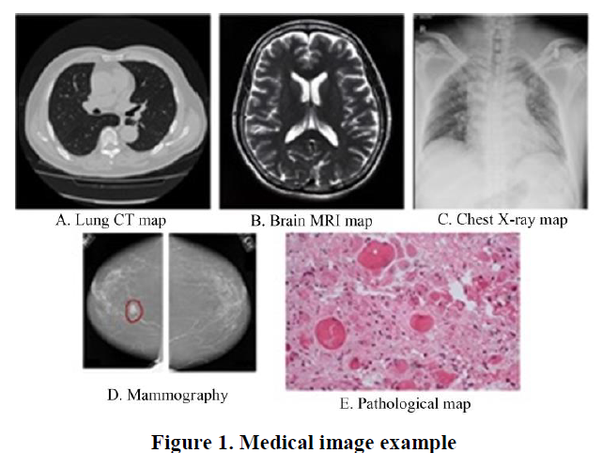

## Computer Vision(CNN) Application for Cancer Detection

Recent surge in use of AI has increased the effectiveness of Machine Learning and Deep Learning and thus it’s inclusiveness in many domains. Medical image analysis is highly dynamic area in machine learning research since machine learning algorithms, especially deep learning techniques represented by convolutional neural networks, have been successfully implemented in computer vision tasks. In it is a representation learning algorithm known as a convolutional neural network (CNN) [15]. It is the most effective machine learning algorithm for image recognition. In the field of medical image processing and also perhaps the most commonly used machine learning algorithm. The key explanation for this is that CNN exactly fits the image's two-dimensional form in structure and uses this spatial relationship as the algorithm's direct input value. This spatial relationship is a critical image function in radiology, like how the edge of a bone binds to muscle or what is the structural relationship between normal lung tissue and cancerous lung tissue. CNN enters the Full Connection Layer via the Convolution Layer, Rectifier Linear Unit Layer, and Pooling Layer with the input image of the initial pixel, and then outputs a classification score or probability rating and the image classification task can be completed. Fig 2.

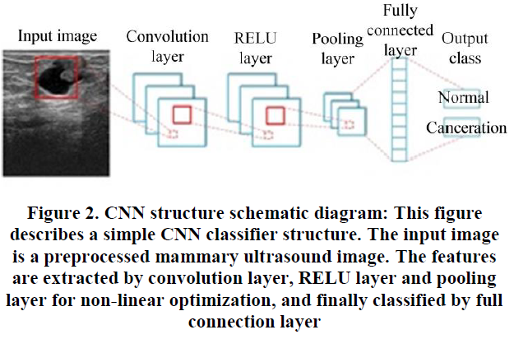

## Convolution Layer:

Convolution is a matrices-to-matrices operation. The first matrix is a two-dimensional structure of the pixel matrix consisting of the image's pixel values point by point in the image analysis process. The second matrix is a filter, or kernel, and convolution is the point product of the two matrices. The filter's size is usually much smaller than the image matrix. It slides the image along a set of steps and strides until the convolution operation has covered the entire image. This is a displacement-invariant, linear operation. It's basically a weighted combination of input image signals at the local level. A weighted matrix is used as the filter matrix. Different properties of the input signal are shown in the selected set of weights (i.e. the selected core), and the simplest low-level features such as lines and edges in the image are received. Simple features are proceeded on to the next layer in the hierarchical processing system of mammalian visual cortex cells such as cats[16]. Layer by layer, basic features are combined to form high-level semantic features, and eventually, different objects are defined.

## RELU Layer:

In CNN networks, convolution computation is a linear process, while the real world is a hugely nonlinear. As a result, the RELU layer must be introduced to increase the network's non-linearity in order to boost the network's complexity and capacity, as well as to better match the task data. It is also called activation function. It sets the negative input value to zero, simplifying the CNN model's training and inference processes, preventing over-fitting to a degree, and solving the problem of gradient disappearance and gradient explosion in the CNN network's training phase [17].

## Pooling Layer:

Between the convolution layer and the RELU layer, a pooling layer, often known as Down-Pooling, is added. The main goal is to enhance the invariance of convolution feature spatial representation and to avoid interference caused by image rotation, translation, and scale changes. Since the outcome of each pooling process, such as maximum and average, is always the equal, even if the image is translated/rotated multiple pixels, the output value is in general the similar if a region is pooled. In order to prevent over-fitting, the pooling layer will combine features from different feature maps and reduce the dimension of feature maps. Simultaneously, it can help preserve the key characteristics, similar to the result of principal component analysis. Maximum pooling, average pooling, and median pooling are the most widely used approaches.

## Fully Connected Layer:

In a CNN network, the last layer is usually the full-connectivity layer, which means that every neuron in the first layer should be connected to every neuron in the second layer. Multiple complete link layers can be configured to meet the requirements of feature abstraction aggregation for particular tasks. The full link layer takes the output of the previous layer (for example, the RELU layer or the pooling layer) as input and calculates the probability scores categorized into the various available groups. This layer's highly triggered feature combinations can also be seen at the same time. A feature thermodynamic diagram can be drawn to help us observe the basis for CNN to classify them into a specific category by labelling the regions of these strong feature combinations at the same place as the original picture.

# Challenges And Conclusion

The only challenge it faces is the use of hierarchical features that are only learned from data and not from manual features on the basis of domain specific knowledge design.

From the above review on both the application of CV and the extent of it’s possibilities in the field of medical domain, it’s pretty clear that in the coming years it will have a significant role to play. This will not just be a boost in terms of reducing the fatalities caused as a effect of the diseases like breast cancer but also improve the performance of the medical processes and bring down the cost of whole treatment.

##### Reference

1. Liu Q.S., He L.Q. Diagnosis Model Based Neutral -network in Galactophore Cancer Cell Identification [J]. Journal of Chongqing University, 2003, 26(4):70-72.
2. Bengio Y., Courville A. C., Vincent P. Representation Learning: A Review and New Perspectives[J]. IEEE Trans. Pattern Anal. Mach. Intell., 2013, 35(8):1798-1828.
3. Hubel D. H., Wiesel T. N. Receptive fields, binocular interaction and functional architecture in the cat’s visual cortex[J]. Journal of Physiology, 1962, 160(1):106-154.
4. Nair V., Hinton G. E. Rectified linear units improve restricted boltzmann machines[A].International Conference on International Conference on Machine Learning[C]. .[S.l.]:[s.n.] , 2010:807-814
5. Lo S. B., Lou S. A., Lin J. S., et al. Artificial convolution neural network techniques and applications for lung nodule detection[J]. IEEE Transactions on Medical Imaging, 1995, 14(4):711.
6. Russakovsky O., Deng J., Su H., et al. ImageNet Large Scale Visual Recognition Challenge[J]. International Journal of Computer Vision, 2015, 115(3):211-252.
7. Yan Z., Zhan Y., Peng Z., et al. Bodypart Recognition Using Multi-stage Deep Learning[A]. Information Processing in Medical Imaging: Conference[C]. .[S.l.]: [s.n.] ,2015:449.
8. Albarqouni S., Baur C., Achilles F., et al. AggNet: Deep Learning From Crowds for Mitosis Detection in Breast Cancer Histology Images[J]. IEEE Trans. Med. Imaging, 2016, 35(5):1313-132
9. Bray, F.; Ferlay, J.; Soerjomataram, I.; Siegel, R.L.; Torre, L.A.; Jemal, A. Global cancer statistics. CA Cancer J. Clin. 2011, 68, 394–424.
10. Nahid, A.-A.; Kong, Y. Involvement of Machine Learning for Breast Cancer Image Classification: A Survey. Comput. Math. Methods Med. 2017, 2017, 3781951
11. Skandalakis, J.E. Embryology and anatomy of the breast. In Breast Augmentation; Springer: Berlin/Heidelberg, Germany, 2009; pp. 3–24.
12. Dheeba, J.; Singh, N.A. Computer aided intelligent breast cancer detection: Second opinion for radiologists—A prospective study. In Computational Intelligence Applications in Modeling and Control; Springer: Cham, Switzerland, 2015; pp. 397–430.
13. Gao, F.; Chia, K.-S.; Ng, F.-C.; Ng, E.-H.; Machin, D. Interval cancers following breast cancer screening in Singaporean women. Int. J. Cancer 2002, 101, 475–479.
14. Chan, H.-P.; Doi, K.; Vybrony, C.J.; Schmidt, R.A.; Metz, C.E.; Lam, K.L.; Ogura, T.;Wu, Y.; MacMahon, H. Improvement in Radiologists?? Detection of Clustered Microcalcifications on Mammograms. Investig. Radiol. 1990, 25, 1102–1110.
15. Munir, K.; Elahi, H.; Ayub, A.; Frezza, F.; Rizzi, A. Cancer Diagnosis Using Deep Learning: A Bibliographic Review. Cancers 2019, 11, 1235.
16. Jackson V. P., Hendrick R. E., Feig S. A., et al. Imaging of the radiographically dense breast.[J]. Radiology, 1993, 188(2):297-301.
17. American Cancer Society. Breast Cancer Facts and Figures 2019; American Cancer Society: Atlanta, GA, USA, 2019.